Session 3 Reading

TISSUE SYSTEMS
There are many different types of basic plant cells and its parts. Similar kinds of cells are organized into structural and functional units, or tissues, which make up the plant as a whole, and new cells (and tissues) are formed at growing points of actively dividing cells. These growing points, called meristems, are located either at the stem and root tips (apical meristems), where they are responsible for the primary growth of plants, or laterally in stems and roots (lateral meristems), where they are responsible for secondary plant growth. Three tissue systems are recognized in vascular plants: dermal, vascular, and ground.
A Dermal System The dermal system consists of the epidermis, or outermost layer, of the plant body. It forms the skin of the plant, covering the leaves, flowers, roots, fruits, and seeds. Epidermal cells vary greatly in function and structure.
The epidermis may contain stomata, openings through which gases are exchanged with the atmosphere. These openings are surrounded by specialized cells called guard cells, which, through changes in their size and shape, alter the size of the stomatal openings and thus regulate the gas exchange. The epidermis is covered with a waxy coating called the cuticle, which functions as a waterproofing layer and thus reduces water loss from the plant surface through evaporation. If the plant undergoes secondary growth—growth that increases the diameter of roots and stems through the activity of lateral meristems—the epidermis is replaced by a peridermis made up of heavily waterproofed cells (mainly cork tissue) that are dead at maturity.
B Vascular System
The vascular tissue system consists of two kinds of conducting tissues: the xylem, responsible for conduction of water and dissolved mineral nutrients, and the phloem, responsible for conduction of food. The xylem also stores food and helps support the plant.
C Ground System The ground, or fundamental, tissue systems of plants consist of three types of tissue. The first, called parenchyma, is found throughout the plant and is living and capable of cell division at maturity. Usually only primary walls are present, and these are uniformly thickened. The cells of parenchyma tissue carry out many specialized physiological functions—for example, photosynthesis, storage, secretion, and wound healing. They also occur in the xylem and phloem tissues.
Collenchyma, the second type of ground tissue, is also living at maturity and is made up of cells with unevenly thickened primary cell walls. Collenchyma tissue is pliable and functions as support tissue in young, growing portions of plants.
Sclerenchyma tissue, the third type, consists of cells that lack protoplasts at maturity and that have thick secondary walls usually containing lignin. Sclerenchyma tissue is important in supporting and strengthening those portions of plants that have finished growing.

PLANT ORGANS
The body of a vascular plant is organized into three general kinds of organs: roots, stems, and leaves. These organs all contain the three kinds of tissue systems mentioned above, but they differ in the way the cells are specialized to carry out different functions.
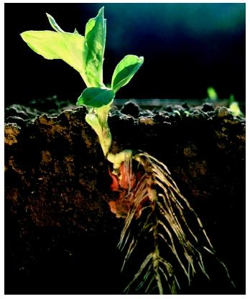
A Roots
The function of roots is to anchor the plant to its substrate and to absorb water and minerals. Thus, roots are generally found underground and grow downward, or in the direction of gravity. Unlike stems, they have no leaves or nodes. The epidermis is just behind the growing tip of roots and is covered with root hairs, which are outgrowths of the epidermal cells. The root hairs increase the surface area of the roots and serve as the surface through which water and nutrients are absorbed.
Internally, roots consist largely of xylem and phloem, although many are highly modified to carry out specialized functions. Thus, some roots are important food and storage organs—for example, beets, carrots, and radishes. Such roots have an abundance of parenchyma tissue. Many tropical trees have aerial prop roots that serve to hold the stem in an upright position. Epiphytes (see Epiphyte) have roots modified for quick absorption of rainwater that flows over the bark of the host plants.
Roots increase in length through the activity of apical meristems and in diameter through the activity of lateral meristems. Branch roots originate internally at some distance behind the growing tip, when certain cells become meristematic.
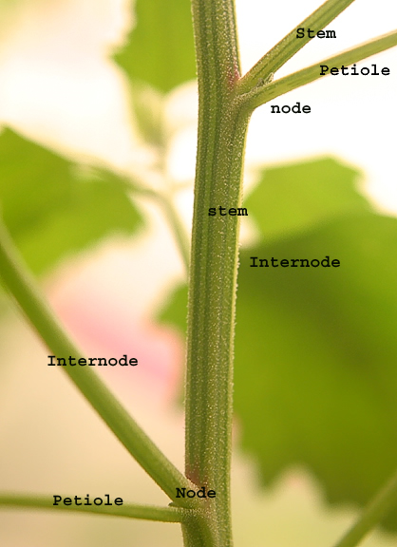
B Stems
Stems usually are above ground, grow upward, and bare leaves, which are attached in a regular pattern at nodes along the stem. The portions of the stem between nodes are called internodes. Stems increase in length through the activity of an apical meristem at the stem tip. This growing point also gives rise to new leaves, which surround and protect the stem tip, or apical bud, before they expand. Apical buds of deciduous trees, which lose their leaves during part of the year, are usually protected by modified leaves called bud scales.
Stems are more variable in external appearance and internal structure than are roots, but they also consist of the three tissue systems and have several features in common. Vascular tissue is present in bundles that run the length of the stem, forming a continuous network with the vascular tissue in the leaves and the roots. The vascular tissue of herbaceous plants is surrounded by parenchyma tissue, whereas the stems of woody plants consist mostly of hard xylem tissue. Stems increase in diameter through the activity of lateral meristems, which produce the bark and wood in woody plants. The bark, which also contains the phloem, serves as a protective outer covering, preventing damage and water loss.
Within the plant kingdom are many modifications of the basic stem, such as the thorns of hawthorns. Climbing stems, such as the tendrils of grapes and Boston ivy, have special modifications that allow them to grow up and attach to their substrate. Many plants have reduced leaves or no leaves at all, and their stems act as the photosynthetic surface (see Cactus). Some stems creep along the surface of the ground and serve to reproduce the plants through vegetative means; many grasses reproduce in this way (see Vegetative Reproduction). Other stems are borne underground and serve as food-storage organs, often allowing the plant to survive through the winter; the so-called bulbs of tulips and crocus are examples.
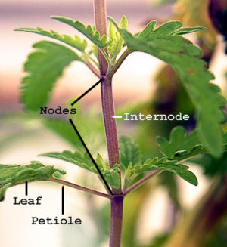
C Leaves
Leaves are the primary photosynthetic organs of most plants. They usually are flattened blades that consist, internally, mostly of parenchyma tissue called the mesophyll, which is made up of loosely arranged cells with spaces between them. The spaces are filled with air, from which the cells absorb carbon dioxide and into which they expel oxygen. The mesophyll is bounded by the upper and lower surface of the leaf blade, which is covered by epidermal tissue. A vascular network runs through the mesophyll, providing the cell walls with water and removing the food products of photosynthesis to other parts of the plants.
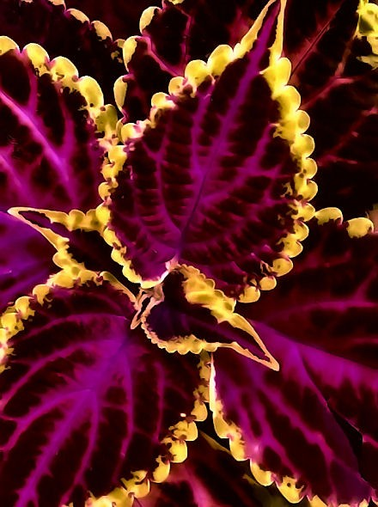
The leaf blade is connected to the stem through a narrowed portion called the petiole, or stalk, which consists mostly of vascular tissue. Appendages called stipules are often present at the base of the petiole.
Many specialized forms of leaves occur. Some are modified as spines, which help protect plants from predators. Certain groups of plants possess highly modified leaves that trap and digest insects, providing needed nutrients (see Insectivorous Plants). Some leaves are brightly colored and petal-like, serving to attract pollinators to otherwise small, unattractive flowers. Perhaps the most highly modified leaves are flowers themselves. The individual parts of flowers—carpels, stamens, petals, and sepals—are all modified leaves that have taken on reproductive functions. See Flower.

