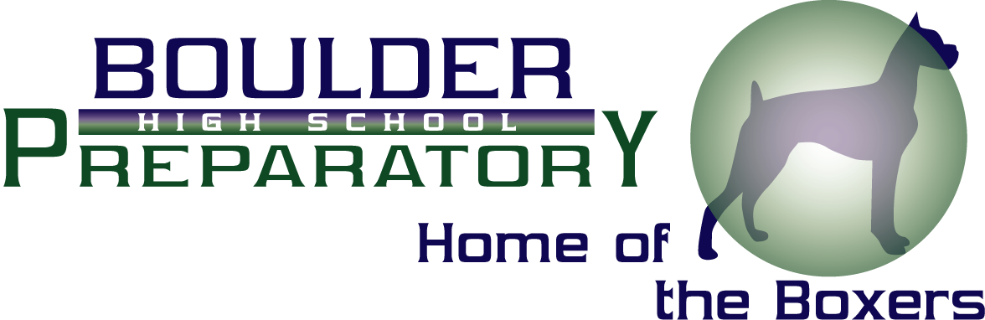

BOULDER PREPARATORY HIGH SCHOOL
2010 BOARD MEETING
November 22nd 6:00-8:00

- Reading and Approval of Minutes

- Open Comment, New Business & Announcements

- Discussion on Board Communication & Process for Resolving Board Issues

- Finance Committee Update Pam, Tina and Rick
Topics discussed at first meeting
Contract for Rick Boos
Request and Administrative Recommendations
for expenditures for Professional Development Stipends
Hiring a full time staff member for Blocks 3
Technology Upgrades

- Board Training Dates for 2011 Nora

- Officer Elections

- Executive Session

- Meeting Adjourned

